Miyazaki International College
Course Syllabus
Fall 2021

Course Title ( Credits ) | LIB102 Introduction to Global Citizenship (2 credits)
Course Designation for TC | N/A
Instructors (email) | Anderson Passos (apassos@sky.miyazaki-mic.ac.jp)
Office/Ext | MIC 1-305 / ext. 3725 (Passos)
Office hours | Passos: Monday to Thursday from 11:00 to 12:00

Course Description:
All citizens are members of local, national, and global communities. For this reason, one of M.I.C.'s educational objectives is to "enable each student to develop as a global citizen." Liberal arts curricula enable students to develop both their cognitive skills and affective dispositions so that they can contribute meaningfully to life in various communities and prepare students for active and responsible citizenship. In this course students will: 1) consider definitions of citizenship, 2) consider the connection between a liberal arts education and life after college, and 3) use critical thinking to approach real-world problems related to the environment, human development, and peace.

Course Goals/Objectives:
General Learning Objectives
In this course, students will learn about global citizenship and be to answer the following questions:
- What is a citizen?
- What are some different definitions of citizenship?
- What do I value as a citizen?
- How does studying at MIC connect with my development as a citizen and life after graduation?
In addition, students will learn about a global issue by examining the following questions:
- What is the nature of the problem?
- How can we understand the problem using different areas of study?
- What are citizens doing about the problem?
- What challenges still remain to solve the problem?

English Skills Objectives
Students will work to improve their knowledge of vocabulary, skills for writing, and skills for speaking fluently, especially as related to the course contents.
The course textbook has specific activities to help you with:
- Vocabulary: Difficult words are listed at the beginning of every unit.
- Writing: Using the new words you have studied, you will be writing your original sentences
- Reading: Every unit has an easy-to-understand reading passage about the unit topic
- Understanding: Multiple choice questions about the reading passage
- Grammar: Open-ended questions to improve your writing.
- Finding mistakes: Further testing your understanding of the unit topic
- Vocabulary swapping: Finding words with similar meaning
- Listening: answer questions and complete spoken sentences
- Discussion: Together with your colleagues, answer additional questions about the unit topic

SDGs Objectives
This course explicitly connects its content to the Sustainable Development Goals. Students will develop a final project with a topic of their choice and will connect it to at least one of the SDGs.
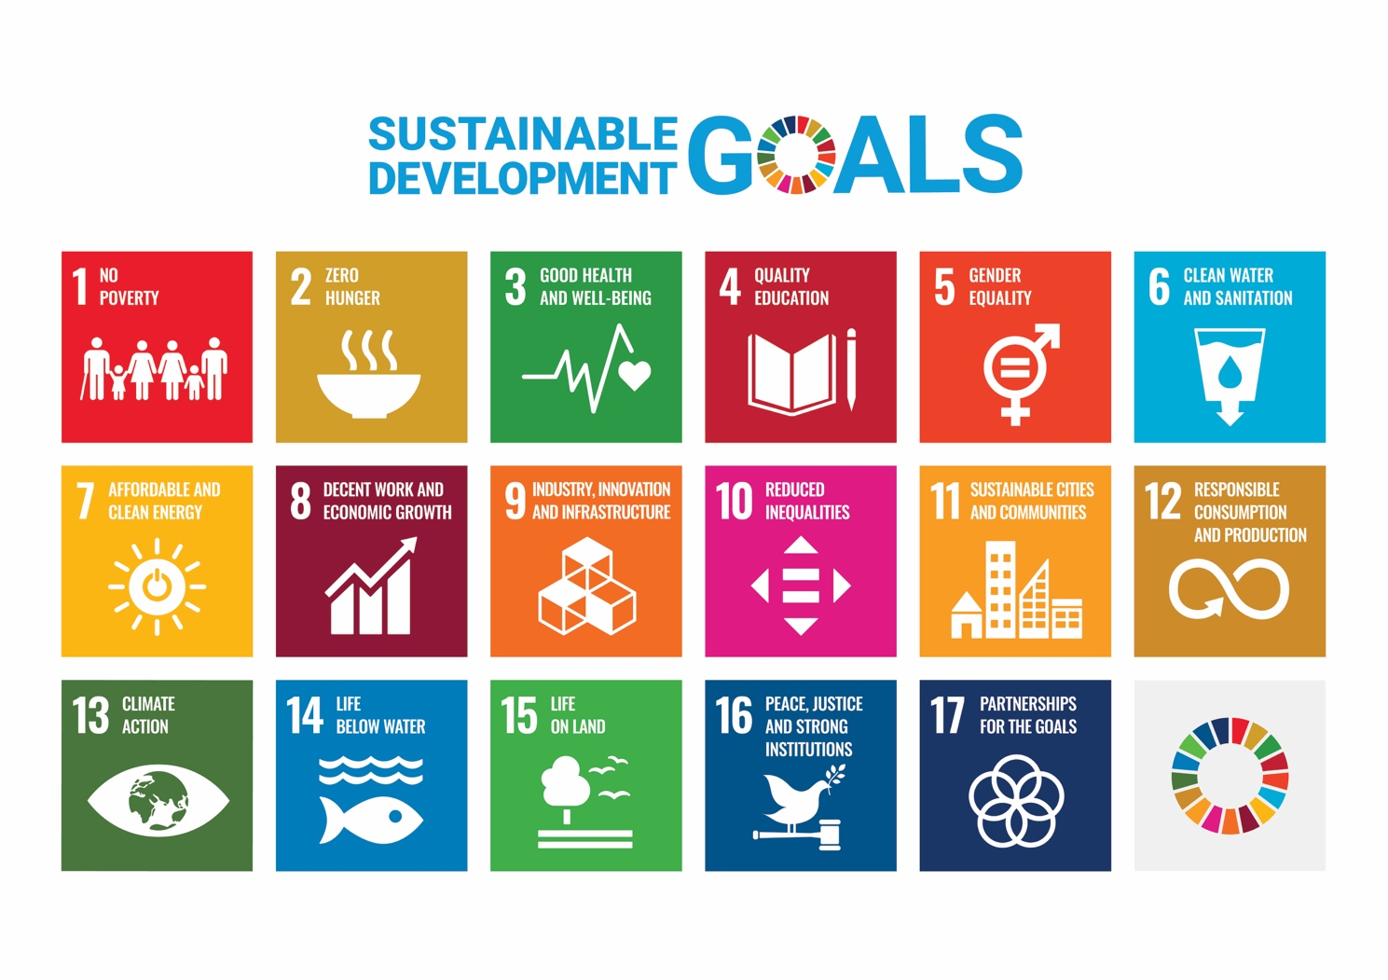

Course Schedule
Day | Topic | Content/Activities
1 | Introduction to Env. Issues and SDGs | Syllabus and introduction to the course topic  - Understanding the syllabus and defining citizenship through individual/group work and discussion  Global citizenship and values  - Analyzing and comparing different concepts of citizenship and considering different citizens’ values through individual and group work and discussion
2 |  | Unit 1: Introduction to Environmental Issues  - Read aloud  - Vocabulary  - Group work
3 |  | Unit 2: Climate Change  - Read aloud  - Vocabulary  - Group work
4 |  | Unit 3: Energy  - Read aloud  - Vocabulary  - Group work
5 |  | Unit 4: Waste  - Read aloud  - Vocabulary  - Group work
6 | Humans and the Environment | Units 1~4 mini test  Unit 6: Population Growth  - Read aloud  - Vocabulary  - Group work
7 |  | Unit 7: Pollution  - Read aloud  - Vocabulary  - Group work
8 |  | Unit 8: Water  - Read aloud  - Vocabulary  - Group work
9 |  | Unit 9: Deforestation  - Read aloud  - Vocabulary  - Group work
10 | Sources of Energy | Units 6~9 mini test  Unit 11 Hydroelectricity  - Read aloud  - Vocabulary  - Group work
11 |  | Unit 12: Solar Panels  - Read aloud  - Vocabulary  - Group work
12 |  | Unit 13: Wind Turbines  - Read aloud  - Vocabulary  - Group work
13 |  | Unit 14 Nuclear Energy  - Read aloud  - Vocabulary  - Group work
14 | Poster Presentations | Units 11~14 mini test  Review lesson:
15 |  | Presentation about things students have learned during the semester.
 | Finals
Required Materials:
This course uses the following textbook:

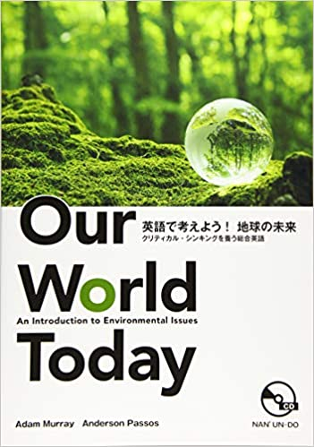
Our World Today
英語で考えよう！地球の未来
クリティカル・シンキングを養う総合英語

ISBN: 9784523178903

Students are expected to have the textbook by the second week of class.

Course Policies (Attendance, etc.)
Attendance and Participation
Students are expected to attend every class. Students with three unexcused absences risk failing the course. Attendance is not part of the grade for this class. Participation is part of the grade, and students must attend class to participate. Students must also compile an e-portfolio using Moodle/Mahara.
Assignment Deadlines
Students must turn in assignments on the due date. Students with an ‘excused absence’ on the due date should submit assignments on the due date via email unless granted an extension by the instructor. Late submissions must be submitted by the following class and will receive half credit.
Academic Integrity
MIC’s Academic Honesty policy prohibits cheating, fabrication, and plagiarism. The Bulletin and Handbook of Student Information explains this policy. Students should understand it and ask the instructor if they have any questions. Violating the Academic Honesty can result in losing all credit (0%) for an assignment, being asked to withdraw from the course, or other appropriate actions.
Class Preparation and Review
As with any college class, students are expected to study course materials outside of class. For this class, students should read each assigned reading before coming to class. It will take approximately two hours to look up new vocabulary, identify and comprehend the main concepts, answer homework questions, and prepare for each class meeting. Finally, students should spend about one hour before class reviewing their notes from previous classes, writing down any questions they have about the lesson, and doing additional research to prepare for class discussion.
In other words, students are expected to spend at least one hour preparing for every hour of lesson, and one hour reviewing and doing Homework. Therefore, because we meet for 90 minutes per week, you should be doing at least 180 minutes preparing and reviewing each week.

Grades and Grading
30% Homework and e-portfolio
30% Tests
20% Poster Presentation
20% Final Exam

Methods of Feedback:
Homework assignments will be graded and returned within a week of submission. Additional comments and feedback will be given verbally in class, but students are encouraged to come to instructor’s office during office hours in case extra explanations are needed.

Your grades are published in Moodle. Make sure to check it and talk to the instructor in case you have any questions.

Diploma Policy Objectives:
Work completed in this course helps students achieve the following Diploma Policy objective(s):
1. Advanced thinking skills (evaluation, comparison, analysis and synthesis) based on critical thinking (critical and analytical thought)
2. The ability to identify and solve problems
3. Advanced communicative proficiency in English
4. Proficiency in the use of information technology

Notes:

 |  | Advanced | Proficient | Developing | Emerging | No Attempt
Critical Thinking | Ability to Identify & Solve Problems | Insightful comments in class discussions  Student shows proven ability to analyze data, gather and assess resources, and disseminate opinions in a scholarly manner. | Able to contribute to class discussions, and to perform a basic analysis of data, gather and assess resources, and express opinions in an adequate manner. | Beginning to visualize the ways in which information can be combined and applied to solving a given problem, but struggles with complex and relationships | Student shows motivation but must learn the concepts and mechanisms that apply to critical thinking, such as information gathering, assessment and synthesis | I had no idea that this student was even enrolled in my class that is how underwhelming this student’s performance was!
 | Information Gathering
 | Assessment of Credibility
Advanced Communication Proficiency | Public Speaking | Speaking is clear, using a broad range of vocabulary and relative jargon. Student uses appropriate social cues and nuance. | Able to create a relevant response when asked to express an opinion or respond to a complicated  situation, but pronunciation and grammar can often make responses and explanations unclear to a listener and must be interpreted. | Able to answer questions and give basic information. However, inconsistent pronunciation, intonation and stress may sometimes make their responses difficult  to understand or interpret. | Student is unsuccessful or finds it very difficult when attempting to explain an opinion or respond to a complicated scenario. The response may be limited to a single sentence or part of a sentence.
 | Social Skills
 | Professional Skills
Global Perspectives | Cultural Relevancy | Fully engaged in current events and shows and understanding of social inequalities and cultural differences. | Student is aware of current events and world cultures, but is unable to apply macro-level situations to her/his own life. | Exhibits interest and intrigue in current events and world culture, but has difficulty understanding relevancy. | Student expresses one-sided ideals from an ethnocentric point of view. Completely lacks awareness of world issues or events.
 | Awareness of Current Events & Global Issues
English Language Ability | Reading | Exhibits fluency/near fluency in speaking and writing. Grammar and reading ability similar to native English speaker. Able to use context clues when faced with unfamiliar vocabulary. | Proficient English ability; relies mainly on familiar vocabulary. Should be encouraged to advanced beyond comfort zone. | Adequate English ability; must reference dictionary often | Student has some English ability, but lacks confidence in using and understanding. Very limited vocabulary knowledge, struggles with grammar and pronunciation Unable to form questions
 | Writing
 | Oral Communication
 | Writing
 | Oral Communication

