Miyazaki International College

Course Syllabus

Fall 2022

Course Title ( Credits ) | SAB201 English (ESL) (6 credits)
Course Designation for TC | N/A
Language Teachers
Instructor | Rebecca Schmidt
E-mail address | rschmidt@sky.miyazaki-mic.ac.jp
Office/Ext | MIC1-401 / 3726
Office hours | Mon, Tue, Thu 16:15 – 17:15 or by appointment.
Instructor | Ellen Head
E-mail address | ehead@ sky.miyazaki-mic.ac.jp
Office/Ext | MIC1-205 / 3715
Office hours | Mon, Tue, Thu 16:15 – 17:15 or by appointment.
Instructor | Jason Adachi
E-mail address | jadachi@ sky.miyazaki-mic.ac.jp
Office/Ext | MIC2-205 / 3782
Office hours | Mon, Tue, Thu 16:15 – 17:15 or by appointment.

Course Description:
Intensive practice in English speaking, reading, writing, and listening. Students are placed in classes according to their level of English proficiency.

This sophomore course focused on developing language and test-taking skills to help students achieve the highest TOEIC score possible by the end-of-semester. Students will broaden their knowledge of vocabulary and grammar while practicing their reading and listening skills.

Course Objectives:
This course aims at improving students’ language skills in all 4 areas: Speaking, listening, reading, and writing.

In addition, students use the many assignments from this course to build up their Study Abroad English portfolio (minimum 3750 words).
Teaching Methodology:
Course objectives will be achieved through a variety of active learning teaching strategies, including but not limited to:

Active Learning Teaching Strategy | Course Schedule
Interactive lectures with note taking | Most classes
Journals | Regular homework
Pair & Group work | Almost every class
Free Discussions | Most classes
Self-assessment through quizzes | As homework every week

Course Schedule (the lesson order will be different according to your section number)
Four Corners: 30 lessons
Lesson | Topic | Content/Activities
1 | Unit 1 Education | Lesson A – I’m taking six classes
2 |  | Lesson B - You’re not allowed to...
3 |  | Lesson C - My behavior
4 |  | Lesson D - Education controversy
5 |  | Unit review and mini test
6 | Unit 2 Personal stories: | Lesson A – What were you doing?
7 |  | Lesson B – Guess what!
8 |  | Lesson C – I was really frightened!
9 |  | Lesson D – How embarrassing!
10 |  | Unit review and mini test
11 | Unit 3 Style and fashion: | Lesson A – Fashion trends
12 |  | Lesson B – Does this come in...?
13 |  | Lesson C – The latest look
14 |  | Lesson D – Views on fashion
15 |  | Unit review and mini test
16 | Unit 4 Interesting lives: | Lesson A – Have you ever been on TV?
17 |  | Lesson B – What I mean is...
18 |  | Lesson C – Life experiences
19 |  | Lesson D – What a life!
20 |  | Unit review and mini test
21 | Unit 5 Our world | Lesson A – Older, taller, and more famous
22 |  | Lesson B – I don’t believe it!
23 |  | Lesson C – World geography
24 |  | Lesson D – Natural wonders
25 |  | Unit review and mini test
26 | Unit 6 Organizing your time | Lesson A – A busy week
27 |  | Lesson B – Can I take a message?
28 |  | Lesson C – Can you do me a favor?
29 |  | Lesson D – Perspectives on time
30 |  | Unit review and mini test

TOEIC: 15 lessons
Lesson | Topic | Content/Activities
1 | Unit 1 Daily Life | Check vocabulary for this unit, complete the listening and perform the quiz (homework)
2 | Unit 2  Places | Check vocabulary for this unit, complete the listening and perform the quiz (homework)
3 | Unit 3  People | Check vocabulary for this unit, complete the listening and perform the quiz (homework)
4 | Unit 4  Travel | Check vocabulary for this unit, complete the listening and perform the quiz (homework)
5 | Unit 5  Business | Check vocabulary for this unit, complete the listening and perform the quiz (homework)
6 | Unit 6  Office | Check vocabulary for this unit, complete the listening and perform the quiz (homework)
7 | Unit 7  Technology | Check vocabulary for this unit, complete the listening and perform the quiz (homework)
8 | Unit 8  Personnel | Check vocabulary for this unit, complete the listening and perform the quiz (homework)
9 | Unit 9  Management | Check vocabulary for this unit, complete the listening and perform the quiz (homework)
10 | Unit 10  Purchasing | Check vocabulary for this unit, complete the listening and perform the quiz (homework)
11 | Unit 11  Finances | Check vocabulary for this unit, complete the listening and perform the quiz (homework)
12 | Unit 12  Media | Check vocabulary for this unit, complete the listening and perform the quiz (homework)
13 | Unit 13  Entertainment | Check vocabulary for this unit, complete the listening and perform the quiz (homework)
14 | Unit 14  Health | Check vocabulary for this unit, complete the listening and perform the quiz (homework)
15 | Unit 15  Restaurants | Check vocabulary for this unit, complete the listening and perform the quiz (homework)

Final Exam
Required Materials:
This course uses the following textbooks:

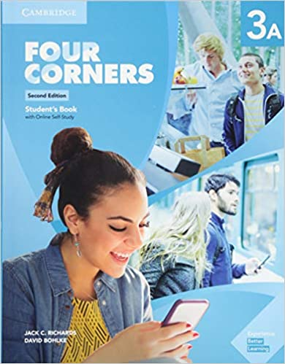
Four Corners 2nd Edition Level 3 Student's Book A with Online Self-Study

ISBN: 9781108559805

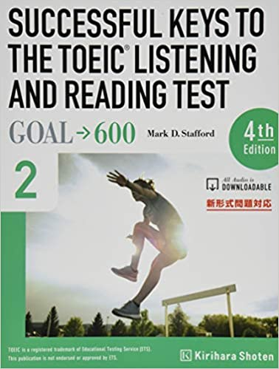
SUCCESSFUL KEYS TO THE TOEIC L/R TEST - GOAL→600

ISBN: 9784342552632

Students are expected to have the textbook by the time the course starts.
Course Policies (Attendance, etc.)
Student Responsibilities
As a class member, you are responsible for attending all classes and arriving on time, for participating as a member of a group, and for completing and handing in all assigned work.

Attendance and Lateness
- You can be absent a maximum of 10 times. Credit cannot be granted to students who have more than 10 absences, even if the final work is extremely good!
- If you are more than 20 minutes late, you will be given an absence
- Two lateness are equal to one absence
If you sum up more than 10 absences (e.g. 9 absences and 3 lateness), you will receive an “X” grade, and will have to take the course again next year.

Homework
The homework should be handed in at the beginning of every class. All homework submitted after that will not be considered.

Excused Absences
Whenever possible, plan in advance and ask the instructors for the material of the class you are going to be absent. Homework and project deadlines will not be changed nor postponed, so plan ahead of time if you have to be absent for a class. Exceptional cases exist, so be sure to talk to the instructor if you have any questions/doubts.

Late Assignments
It is your responsibility to look for the course instructor and check what assignments are due.
Also, if you miss a class, it is your responsibility to contact the instructor to get handouts and explanations (missing a class is no excuse for not handing in homework).

Plagiarism and Intellectual Honesty
Plagiarism is representing someone else's intellectual property, words, ideas, or images, as your own. It is a very serious academic offense and plagiarized work is not accepted in this course. Ask one of the instructors if you have any questions about this. You are responsible for understanding what plagiarism is and knowing how to avoid it in your work.

Class Preparation and Review
Students are expected to spend at least one hour preparing for every hour of lesson, and one hour reviewing and doing homework. Make sure you review your notes after each class and make sure you understand the topics covered. Instructors are available outside the classroom in case students need additional assistance (Please check office hours on the first page of this syllabus).

Very often, you will have homework assignments. Make sure you review those before coming to the next class. Also, check the class Content/Activities so you can be prepared for the class.
Grades and Grading Standards
Homework: 30%
Participation: 30%
Final report submission (3750 words): 40%

This is a Pass/Fail course. Students who receive less than 60% on their grading or fail to submit a final report, will receive an “X” grade, and will have to take the course again next year.

Methods of Feedback:
Homework assignments will be graded and returned within two weeks of submission. Additional comments and feedback will be given verbally in class, but students are encouraged to come to instructor’s office during office hours in case extra explanations are needed.
Diploma Policy Objectives:
Work completed in this course helps students achieve the following Diploma Policy objective(s):
1.Advanced thinking skills (comparison, analysis, synthesis, and evaluation) based on critical thinking (critical and analytic thought)
2.The ability to understand and accept different cultures developed through acquisition of a broad knowledge and comparison of the cultures of Japan and other nations
3.The ability to identify and solve problems

Notes:
The content of classes can be connected to many SDGs. Instructors will encourage students to make these connections when writing their homework assignments and/or in the final report.

